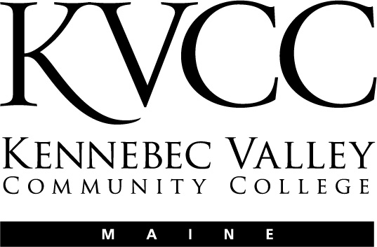
KENNEBEC VALLEY COMMUNITY COLLEGE

FAIRFIELD, MAINE

Social Sciences Department

Approval Date: 5/20/15
Semester: Fall 2016

COURSE NUMBER: | MHT 101 | CREDIT HOURS: | 1
COURSE TITLE: | Mental Health Seminar | CLOCK HOURS: | 15
PREREQUISITES: | None
CO-REQUISITES: | None

INSTRUCTOR | VOICE MAIL | OFFICE | E-MAIL ADDRESS
See Blackboard | For contact | Information
OFFICE HOURS: | TBA

TEXTS & OTHER MATERIALS:
All the course materials for this class are on Blackboard

COURSE DESCRIPTION:

This course is designed as an introductory seminar in which students will have the opportunity to explore the overall building blocks for success in college. They will develop an understanding that the journey of college is a time of personal growth and change and the start of a new identity. The course will help students acclimate to life at Kennebec Valley Community College (KVCC), and provide them with opportunities to acquire knowledge and skills that will contribute to their success at KVCC.
COURSE OBJECTIVES:

Upon successful completion of this course, the student should be able to:

- Identify the role and responsibility of being a college student.
- Practice effective communication skills.
- Demonstrate time management strategies.
- Identify strategies for learning related to personal learning styles.
- Identify various student services resources at KVCC and when their use is warranted.
- Demonstrate proficiency in KVCC supported technologies (Bb, Email, Portal, etc.)
- Demonstrate proficiency in Mental Health Program supported technologies.
- Reflect upon the concepts of diversity, multiculturalism, and unconditional positive regard as it applies to the role of the student and to mental health rehabilitation practice.
- Apply concepts of professional boundary management.
- Apply concepts of professional self-care management.
- Demonstrate proficiency in working in groups.
- Identify immediate and long-term educational goals.
- Create a career plan.

COURSE CONTENT:

Lesson 1: Introduction and Orientation
Lesson 2: Is the Mental Health field the right career for me?
Lesson 3: Is KVCC’s Mental Health Program the right path for me?
Lesson 4: How to be a Successful College Student
Lesson 5: Professionalism – Communication, Boundaries, and Self-Care
Lesson 6: Working in Groups
Lesson 7: Making Connections and Planning your Career

COURSE ACTIVITIES:
For each week in this class you will be assigned specific activities. These activities may include reading in the textbook, reading outside material, participation in discussions, quizzes on the text content, and reflection quizzes.

Lesson Plans

The entire course is divided into “Lessons” that cover specific topics and learning objectives in the class. The Lessons are listed in the Course Outline above. Each Lesson introduces you to specific subject matter and asks you to engage in a number of activities. These may include reading, exploring the web, researching, participating in online discussions, quizzes (multiple choice, short answer, and essay questions), and assignments (written work submitted as an attached document in a “drop box”)

Each Lesson consists of:

- A Lesson Plan that outlines the content and provides detailed instructions as to any assignments
- Direct links to any Discussions, Assignments, or Quizzes that go along with that Lesson.

All the Lessons are located in the “Lessons” folder. Click on the Lessons link in the course Menu.

Online Discussions

Online discussions form the backbone of an online class. It is very important for you to participate actively and fully in these discussions. These discussions will be graded and will be available for a specified amount of time (Monday morning until Sunday night on a given week in the course). You are required to participate in these discussions following the instructions that will be provided to you in the online Lessons.

Grading of the online discussions will be done in accordance to this grading rubric:

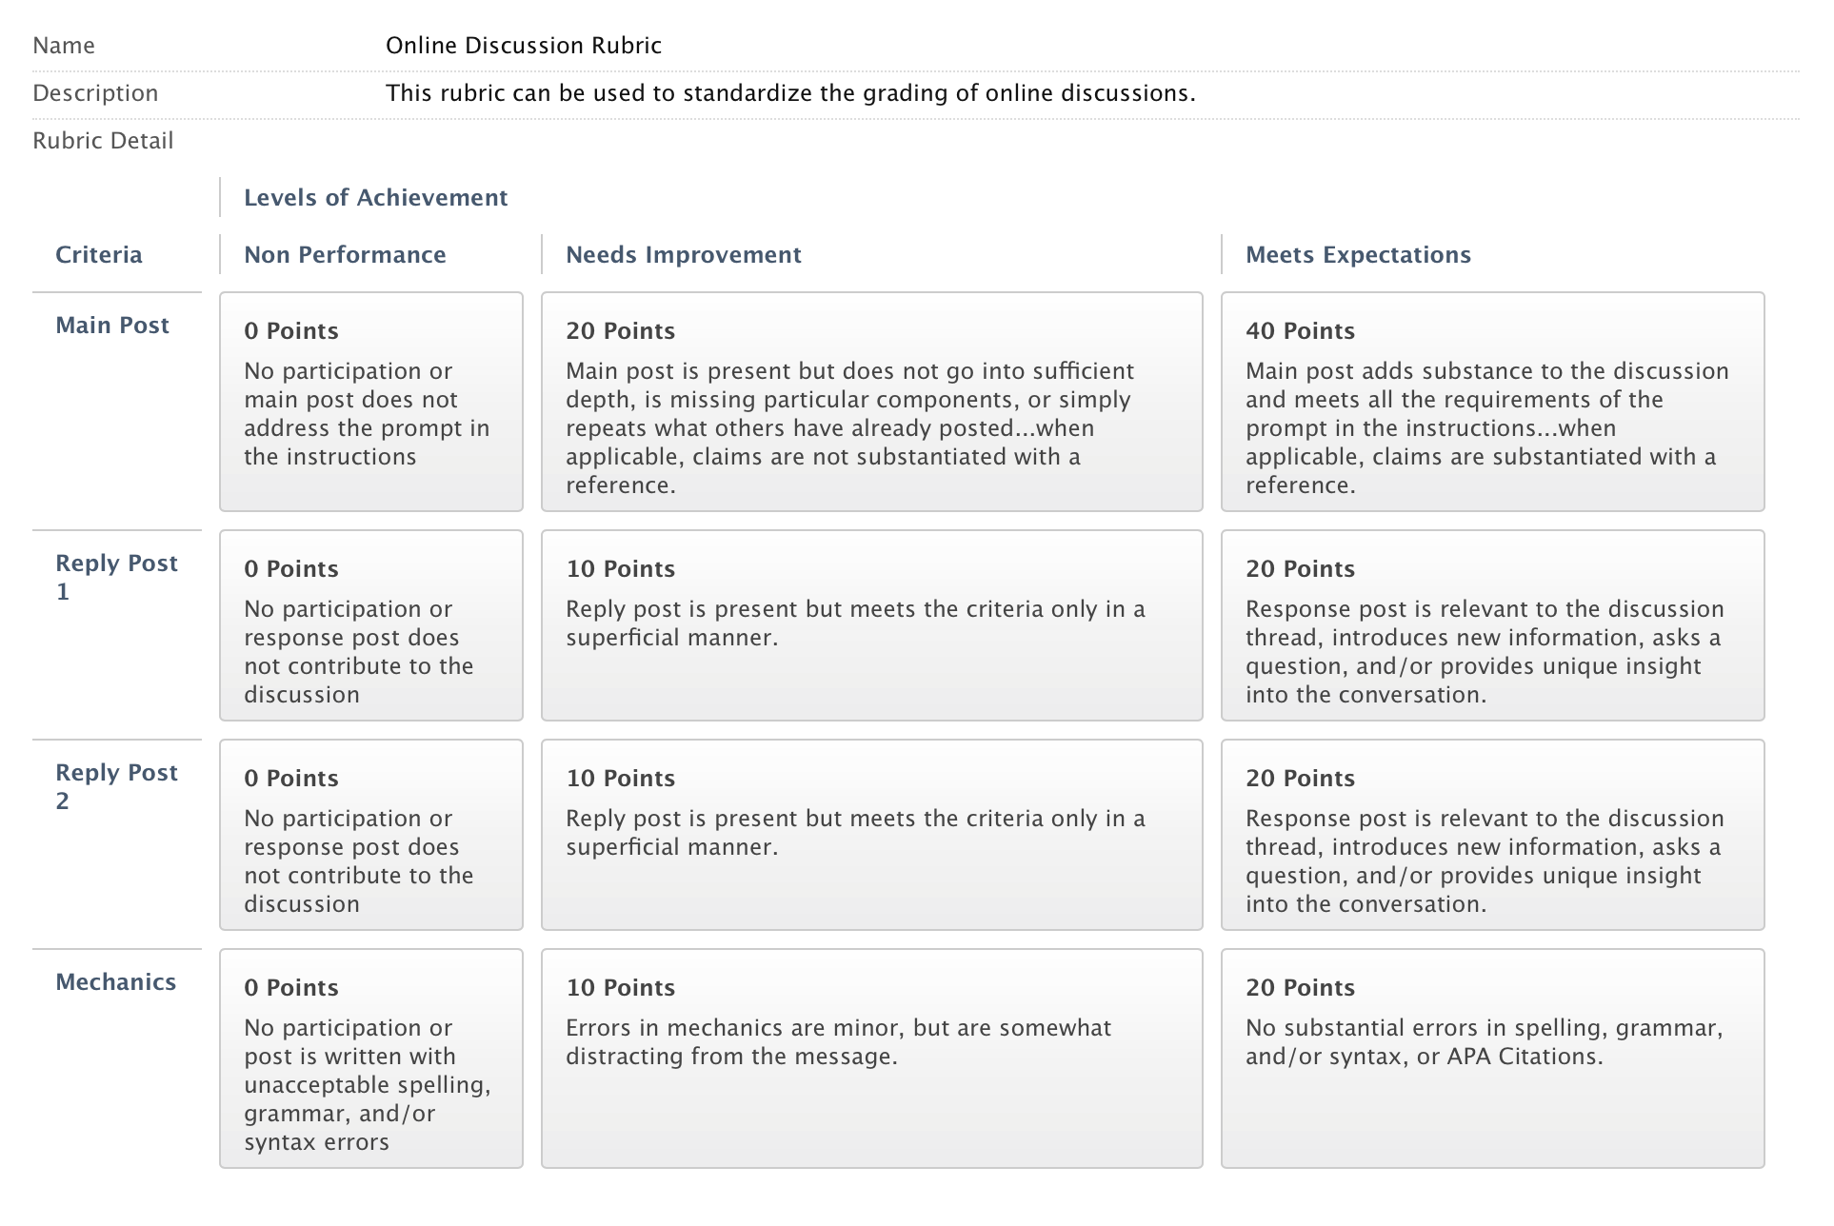

You are, of course, encouraged to post many times through the week. You are also encourages to post EARLY in the week so that you can benefit from others’ responses to your post and so that others may benefit from your responses).

Please review the online document titled “Course Expectations and Policies”

Lesson Quizzes/Assignments

Within the Lesson Plans you will be provided with a lists of ALL the questions included in the Lesson Quiz and/or directions related to the Lesson Assignment. The quizzes are all multiple choince and you have 2 attempts on each one.

Quizzes/assignments must be completed by the end of the week in which they are assigned. You may be able to work ahead on some of these as well.

Extensions on the due dates for quizzes/assignments may be allowed with sufficient reason; however, I reserve the judgment to not grant an extension. If you anticipate needing extra time it is best to get in touch with me PRIOR to the due date.
GRADING:
Grading for the course will be accomplished in the following manner:

  - Graded Discussions 50%
  - Lesson Quizzes/Assignments 50%

GRADING SCALE:
Letter Grades---Based on a final grade scale of 0-100, the following letter grades will be assigned:

  - A
  - A-
  - B+
  - B
  - B-
  - C+
  - C
Below 73 F

Please note that I will not be giving grades below a C. The rationale to this is that students who do not master more than 72% of the material in this class are not prepared to meet the expectations of future classes or programs that require this course. It simply means that you have not learned enough material to really say that you have “passed” the class.
ATTENDANCE POLICY:
Please review the online document titled “Course Expectations and Policies”
COURSE REQUIREMENTS:
N/A
OTHER INFORMATION:
Please review the online document titled “Course Expectations and Policies”

STUDENTS WITH DISABILITIES (2011)

In accordance with state and federal law, this College is committed to assisting qualified students with disabilities achieve their educational goals.

If you are in need of an accommodation in this course:
• Students must contact the Dean of Students, Enrollment Services Center, Frye Building, 453-5019,
knormandin@kvcc.me.edu
• Students must provide current, appropriate documentation of their disability.
• Students must make a timely request for accommodation to the Dean of Students.
• Accommodations will not be provided until the faculty member receives a letter requesting accommodations. This letter is created with the Dean of Students and is supported by the documentation of said disability.
• Requests for accommodation must be renewed each semester for each course.
This document is available in enlarged print and on audio tape. Please contact the Dean of Students at 453-5019 or knormandin@kvcc.me.edu

NOTICE OF NON-DISCRIMINATION (2014):

Kennebec Valley Community College does not discriminate on the basis of disability in the admission to, access to, or operation of its programs, services or activities. Students requesting classroom accommodation should be forwarded to the Dean of Students, Enrollment Service Center, Frye Building, phone: 453-5019 or the Director of the Learning Commons, Lunder Library, phone: 453-5084

Complaints about College decisions related to disability accommodations or discrimination must be forwarded to Affirmative Action Officer and ADA Compliance Officer, Dean of Academic Affairs, Enrollment Services Center, 92 Western Avenue, Fairfield, ME 04937, phone: 453-5822.

